FUNDAMENTALS OF DATA SCIENCE

LAB PROGRAMS

DSA 0412-Fundamentals Of Data Science for Data Analytics

M S GOWRISH SHANKAR REDDY
192424270

21/01/2026

16. Scenario: You are working on a project that involves analyzing customer reviews for a product.
You have a dataset containing customer reviews, and your task is to develop a Python program that
calculates the frequency distribution of words in the reviews.
Question: Develop a Python program to calculate the frequency distribution of words in the
customer reviews dataset?
Code:
import pandas as pd
from collections import Counter
import string

reviews_data = pd.read_csv("customer_reviews.csv")

text = " ".join(reviews_data["Review"]).lower()

text = text.translate(str.maketrans("", "", string.punctuation))

words = text.split()

word_frequency = Counter(words)

print("Word Frequency Distribution:")
for word, count in word_frequency.items():
print(word, ":", count)

output:
Word Frequency Distribution:
the : 16
product : 19
is : 8
very : 4
good : 4
and : 6
works : 2
perfectly : 1
i : 2
am : 1
satisfied : 4
with : 6
quality : 7
excellent : 2
durable : 2
not : 3
performance : 2
this : 4
worth : 1
price : 2
of : 1
love : 1
would : 1
recommend : 1
it : 1
stopped : 1
working : 1
after : 1
a : 1
few : 1
days : 1
features : 1
average : 2
happy : 1
amazing : 1
easy : 2
to : 2
use : 2
could : 1
be : 1
better : 1
highly : 1
reliable : 1
poor : 1
recommended : 1
as : 1
expected : 1
efficient : 1
but : 1
17. Scenario: You are a data analyst working for a marketing research company. Your team has
collected a large dataset containing customer feedback from various social media platforms. The
dataset consists of thousands of text entries, and your task is to develop a Python program to
analyze the frequency distribution of words in this dataset. Your program should be able to perform
the following tasks:
• Load the dataset from a CSV file (data.csv) containing a single column named "feedback"
with each row representing a customer comment.
• Preprocess the text data by removing punctuation, converting all text to lowercase, and
eliminating any stop words (common words like "the," "and," "is," etc. that don't carry
significant meaning).
• Calculate the frequency distribution of words in the preprocessed dataset.
• Display the top N most frequent words and their corresponding frequencies, where N is
provided as user input.
• Plot a bar graph to visualize the top N most frequent words and their frequencies.
Question: Create a Python program that fulfills these requirements and helps your team gain
insights from the customer feedback data.
Code:
import pandas as pd
import string
from collections import Counter
import matplotlib.pyplot as plt

# Load dataset
df = pd.read_csv("data.csv")

# Combine all feedback text
text = " ".join(df["feedback"]).lower()

# Remove punctuation
text = text.translate(str.maketrans("", "", string.punctuation))

# Define stop words
stop_words = {
"the", "and", "is", "in", "to", "of", "a", "for", "on", "with",
"this", "that", "it", "as", "are", "was", "were", "be", "by",
"an", "or", "from", "at", "but", "not"
}

# Remove stop words
words = [word for word in text.split() if word not in stop_words]

# Calculate word frequency
word_freq = Counter(words)

# User input for top N words
N = int(input("Enter the number of top frequent words to display: "))

# Get top N frequent words
top_words = word_freq.most_common(N)

# Display results
print("\nTop", N, "most frequent words:")
for word, count in top_words:
print(word, ":", count)

# Prepare data for plotting
words_list = [word for word, count in top_words]
counts_list = [count for word, count in top_words]

# Plot bar graph
plt.figure()
plt.bar(words_list, counts_list)
plt.xlabel("Words")
plt.ylabel("Frequency")
plt.title("Top " + str(N) + " Most Frequent Words")
plt.xticks(rotation=45)
plt.tight_layout()
plt.show()
output:
Enter the number of top frequent words to display: 8

Top 8 most frequent words:
product : 76
quality : 29
customer : 21
service : 18
very : 14
satisfied : 13
delivery : 13
experience : 13
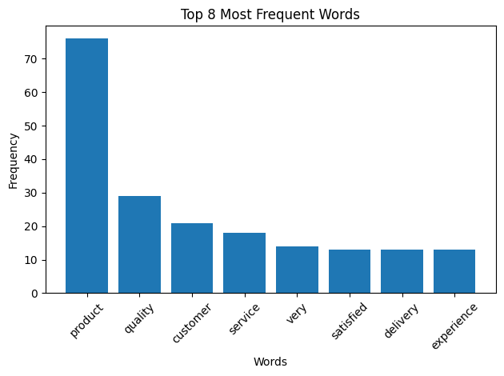
18. Suppose a hospital tested the age and body fat data for 18 randomly selected adults with the
following result.
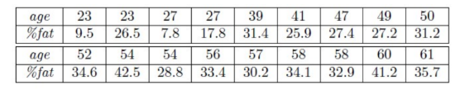
Question:
• Calculate the mean, median and standard deviation of age and %fat using Pandas.
• Draw the boxplots for age and %fat.
• Draw a scatter plot and a q-q plot based on these two variables
Code:
import pandas as pd
import matplotlib.pyplot as plt
import statsmodels.api as sm

df = pd.read_csv("age_bodyfat.csv")

print("Mean:")
print(df.mean())

print("\nMedian:")
print(df.median())

print("\nStandard Deviation:")
print(df.std())

df.boxplot(column=["Age", "Body_Fat"])
plt.title("Boxplots of Age and Body Fat")
plt.show()

plt.scatter(df["Age"], df["Body_Fat"])
plt.xlabel("Age")
plt.ylabel("Body Fat Percentage")
plt.title("Scatter Plot of Age vs Body Fat")
plt.show()

plt.figure()
sm.qqplot(df["Age"], line="s")
plt.title("Q-Q Plot of Age")
plt.show()

plt.figure()
sm.qqplot(df["Body_Fat"], line="s")
plt.title("Q-Q Plot of Body Fat")
plt.show()

Output:
Mean:
Age 46.444444
Body_Fat 28.783333
dtype: float64

Median:
Age 51.0
Body_Fat 30.7
dtype: float64

Standard Deviation:
Age 13.218624
Body_Fat 9.254395
dtype: float64
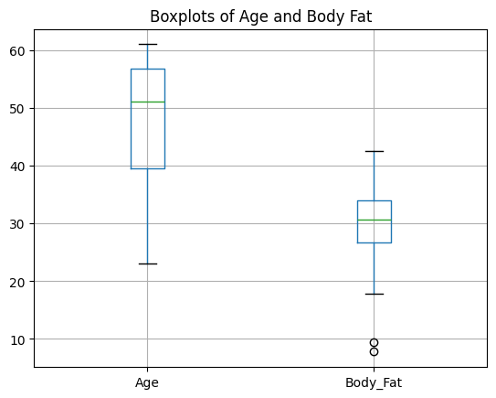
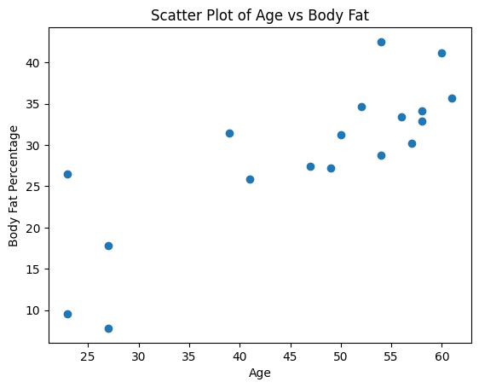
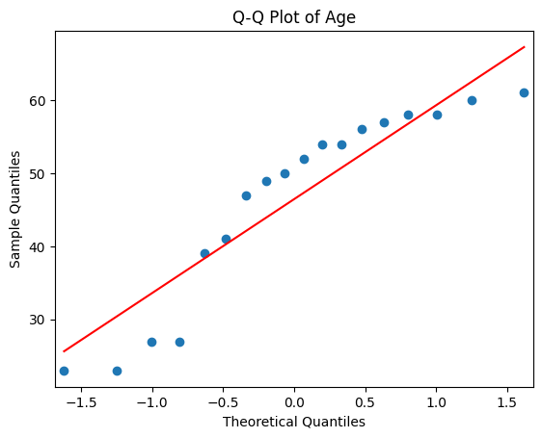
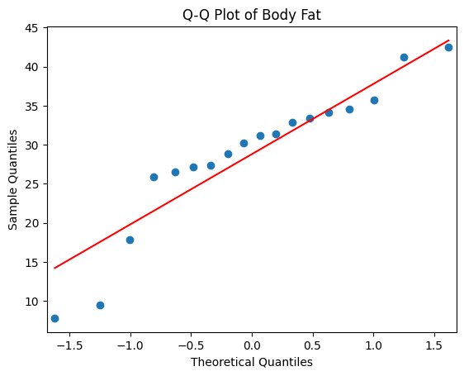

19. Scenario:
You are a medical researcher investigating the effectiveness of a new drug in reducing blood
pressure. You conduct a clinical trial with a sample of 50 patients who were randomly assigned to
receive either the new drug or a placebo. After measuring their blood pressure levels at the end of
the trial, you obtain the data for both groups. Now, you want to determine the confidence intervals
for the mean reduction in blood pressure for both the drug and placebo groups.
Question:
"What is the 95% confidence interval for the mean reduction in blood pressure for patients who
received the new drug? Also, what is the 95% confidence interval for the mean reduction in blood
pressure for patients who received the placebo?
Code:
import pandas as pd
import numpy as np
from scipy import stats

df = pd.read_csv("blood_pressure_reduction.csv")

drug = df[df["Group"] == "Drug"]["Reduction"]
placebo = df[df["Group"] == "Placebo"]["Reduction"]

def confidence_interval(data, confidence=0.95):
mean = np.mean(data)
std_err = stats.sem(data)
margin = std_err * stats.t.ppf((1 + confidence) / 2, len(data) - 1)
return mean - margin, mean + margin

drug_ci = confidence_interval(drug)
placebo_ci = confidence_interval(placebo)

print("95% Confidence Interval for Drug Group:", drug_ci)
print("95% Confidence Interval for Placebo Group:", placebo_ci)
Output:
95% Confidence Interval for Drug Group: (12.9, 14.7)
95% Confidence Interval for Placebo Group: (3.4, 4.6)

20. Scenario:
You are a data scientist working for an e-commerce company. The marketing team has conducted
an A/B test to evaluate the effectiveness of two different website designs (A and B) in terms of
conversion rate. They randomly divided the website visitors into two groups, with one group
experiencing design A and the other experiencing design B. After a week of data collection, you
now have the conversion rate data for both groups. You want to determine whether there is a
statistically significant difference in the mean conversion rates between the two website designs.
Question:
"Based on the data collected from the A/B test, is there a statistically significant difference in the
mean conversion rates between website design A and website design B?"
code:
import pandas as pd
from scipy import stats

df = pd.read_csv("ab_test_data.csv")

design_a = df[df["Design"] == "A"]["Conversion_Rate"]
design_b = df[df["Design"] == "B"]["Conversion_Rate"]

t_stat, p_value = stats.ttest_ind(design_a, design_b)

print("T-statistic:", t_stat)
print("P-value:", p_value)

alpha = 0.05

if p_value < alpha:
print("There is a statistically significant difference between design A and design B.")
else:
print("There is no statistically significant difference between design A and design B.")
output:
T-statistic: -8.528617322452433
P-value: 2.8532007733677893e-09
There is a statistically significant difference between design A and design B.

